**Q1) Program to implement non token based algorithm for Mutual Exclusion**

***A non-token based algorithm*** for mutual exclusion aims to ensure that only one process can access a critical section at a time without using tokens. One such algorithm is the ***Lamport's Bakery Algorithm.***

A non-token based algorithm, in the context of mutual exclusion and distributed systems, is a mechanism for coordinating and controlling access to shared resources without the use of explicit tokens. Token-based algorithms rely on the passing of tokens, physical or virtual, among processes or threads to determine which one has the right to access a critical section or a shared resource. Non-token based algorithms, on the other hand, achieve mutual exclusion through other means, often without the need for a token to be explicitly passed.

***A non-token based algorithm for mutual exclusion*** is a mechanism or approach used to ensure that only one process can access a critical section or shared resource at a time without the use of explicit tokens. In other words, it achieves mutual exclusion without relying on a physical or logical token that is passed between processes to indicate permission for access. Non-token based algorithms use different methods and techniques to coordinate and control access to shared resources. One of the most well-known non-token based algorithms is Lamport's Bakery Algorithm, which I mentioned earlier.

***Lamport's Bakery Algorithm***, named after its creator, Leslie Lamport, is a classical and simple algorithm for achieving mutual exclusion among multiple processes or threads. It ensures that only one process can access a critical section at a time without the use of tokens. This algorithm is often used in concurrent computing and distributed systems to prevent race conditions and guarantee exclusive access to shared resources.

**C++ CODE:**

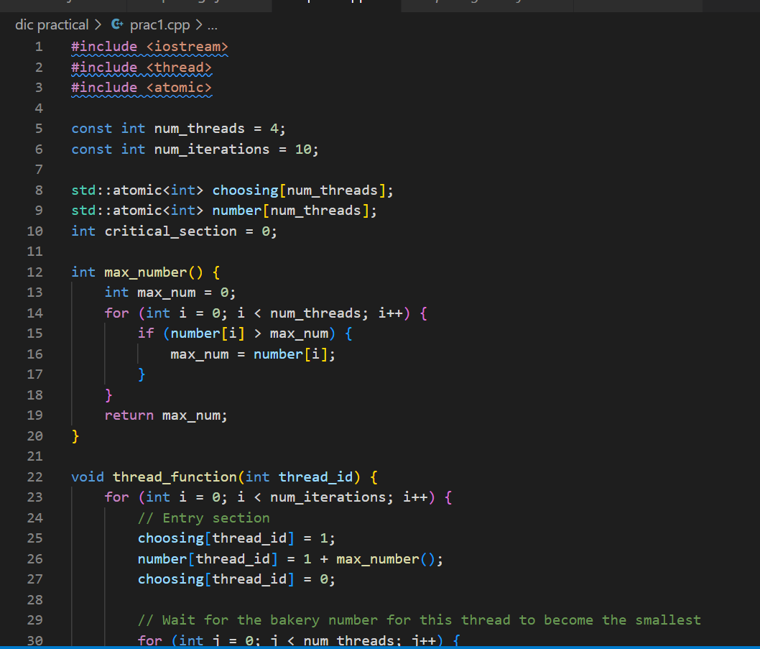

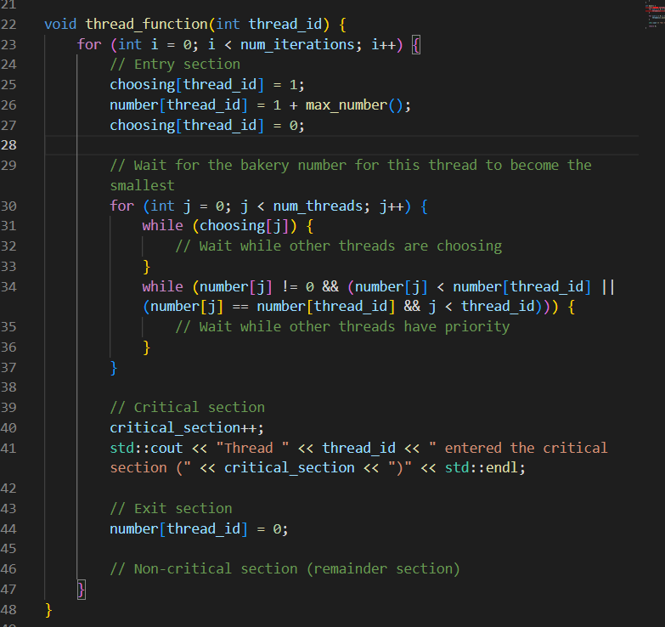

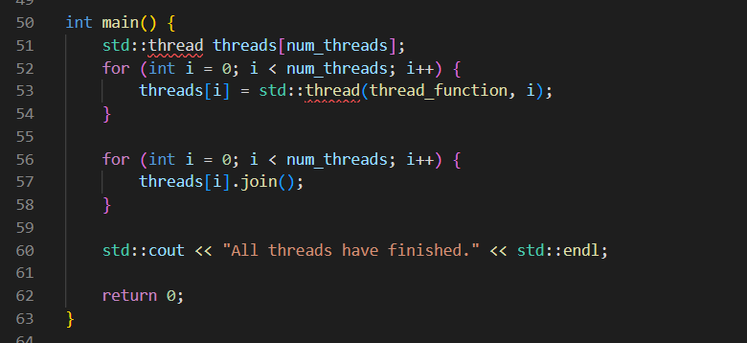

**INPUT:**

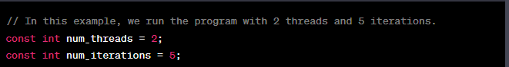

**OUTPUT:**

